**Computer Hardware Guide**

(Project for Systems 3)

Marko Taleski

**Definition of the problem:**

At the present time nearly everyone has access to a computer, whether that be a smartphone, a tablet, a laptop or a PC. The computer has proven itself as the most useful and revolutionary invention man has ever crated. As a matter of fact some type of a computer can be found in all electronics we use in our day to day lives.

A part of what makes a computer live is its hardware. Hardware as a term implies the physical parts of the computer, such as GPU, CPU, power unit and many more. With extensive use of the computer some hardware components may fail and malfunction, which consecutively will lead to the computer cease to function. Getting these malfunctioning or broken components can be very expensive, even replacing the damaged components with a newly bought ones can be expensive. The question the arises why pay an expensive fee to get these components fixed or changed when you could do it yourself just by watching one to two videos.

As a project for Systems 3, I want to develop an information system that can help people distinguish between the all the hardware components, understand their function, how to install that specific component into the motherboard, how to fix certain components.

**Functional requirements:**

1. The system should include a process where every user first must register with valid email address and a password to be able to create an account on the website, where they will be able to use the features of the website.
2. The system must allow the users to create their project on the website where they can edit the attributes they uploaded to the project such as the video and description of the video, the project can also be deleted if the user is not satisfied with it.
3. System should provide a home page where people can explore other user projects that have been grouped into categories instead of searching for projects using the search bar.
4. A requirement to the user projects is that it must contain a component name, it’s serial number and a valid description of the solution being shown on the video or a valid description regarding the instillation of the component.
5. The system must contain a comment section on every project, where other users can comment their opinion to the existing project.
6. The system must contain guidelines which users must follow such as: no profanity, no explicit content should be uploaded, no discrimination etc.

**Non-Functional Requirements:**

1. The system should be able to contain 3000 project uploads per minute or two.
2. The system should provide date when a project was uploaded, also date on each comment to have information of how current the comment.
3. The system can be developed in approximately 2 month to 3 months since the website won’t contain many complicated parts.
4. Access to the system will be available anyone since it is a free website any person can create an account.
5. The system should include a document that states the Terms of Service and tutorial on how to operate the website, whether that be in video or text form.
6. The privacy requirements for creating an account in the system are only: Name, Last name, Email address.
7. The system should contain two types of users, that being the users and administrators. The administrators will keep the website in check and remove comments and projects which go against the guidelines of the system.
8. The system must ensure 24/7 operation with an uptime of at least 90%.

**Feasibility Study:**

In today’s world it’s unavoidable to own a computer, and with owning a computer comes the possibility that some hardware piece might fail, so there is a need for people who need to fix some chip in their computer or install a specific chip onto their motherboard, now they can learn how to with this website. It needs to be accessible for everyone with an internet connection and should be a simple layout displaying categories of hardware piece’s that contain videos that explain how to fix the problem.

It is economically and operationally feasible because it is a task that is done by many computer stores, the website would just a guide to help people do it themselves.

It should be acceptable for everyone who wishes to use it or needs to use it and it’s going to be free to use, the website will not request any personal information from the user apart from his basic contact information. The difficult part of this system would be the involvement of people into the website, because it is depended on user inputs and reviews, since the system would be mainly user uploaded videos. The project is economically viable, it is not expensive to create or expensive to sustain, the only finances is the need for using a server to keep the website running 24/7.

**Matrix user role/functions:**

|  |  |  |
| --- | --- | --- |
| **Functions** | **User** | **Administrator** |
| Function 1 | Yes | Yes |
| Function 2 | Yes | Yes |
| Function 3 | Yes | Yes |
| Function 4 | Yes | Yes |
| Function 5 | Yes | Yes |
| Function 6 | Yes | Yes |
| Function 7 | No | Yes |

**Data dictionary:**

|  |  |  |  |  |
| --- | --- | --- | --- | --- |
| **Entity** | **Description** | **Attribute** | **Type** | **Description of attribute** |
| User | User of system | id | int | Identity of the user |
| name | varchar(20) | First name of the user |
| last_name | varchar(20) | Last name of the user |
| role | boolean | True if user is admin, else false |
|  | | | | |
| Video | Video of possible fix or how to install the chip  Uploaded by the user | id | int | Identity of the video |
| title | varchar(50) | Name of the video |
| duration | int | Duration of the video |
| description | varchar(300) | Description of the solution or the instillation showed in the video |
| serial_number | Int | Serial number of the component |
|  | | | | |
| User Videos | Place where all of the videos are uploaded and stored by user | number_of_videos | int | Number of videos uploaded by a user |
| date_of_video | date | Date of each video uploaded |
|  | | | | |
| Comments | Section where users leave comments on video | number_of_comments | int | The number of com on the video |
| comment | varchar(300) | Comment left by the user |
| rating | int | Like=+1, Dislike=-1 |
|  | | | | |
| Reports | Report of video/comment for breaking the guidelines | number_of_reports | int | Number of reports on the video or comment |
| report | varchar(300) | The report text |
| guidelines | int | Select which guidelines it is breaking |
|  | | | | |
| Guidelines | Rules of the system, if a rule is broken admin removes the video or comment | id | int | Identity of the guideline |
| name_of_rule | varchar(30) | Name of the rule |
| context_of_rule | varchar(100) | Context of the rule |
| number_of_rules | int | Number of Guideline rules |

**Entity relational diagram (ERD)**

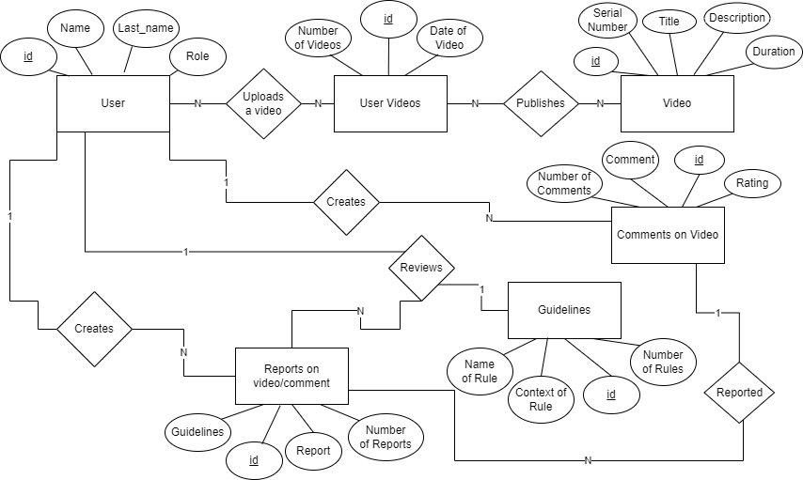

*Figure 1: Entity Relationship Diagram of the system*

**Relational model:**

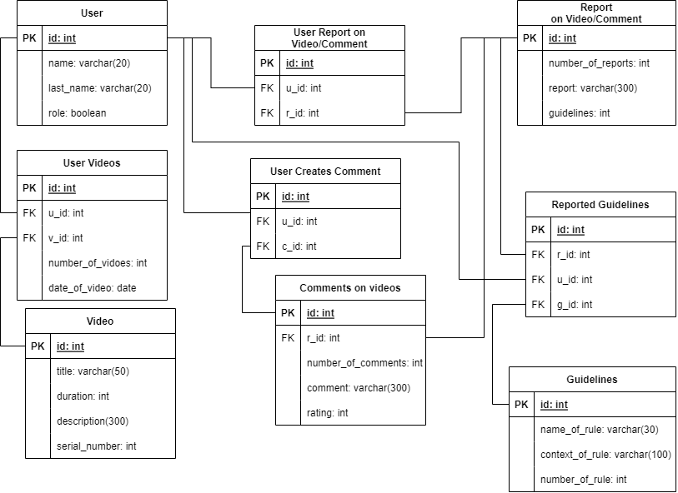

*Figure 2: Relational model of the system*

**UML Class diagram:**

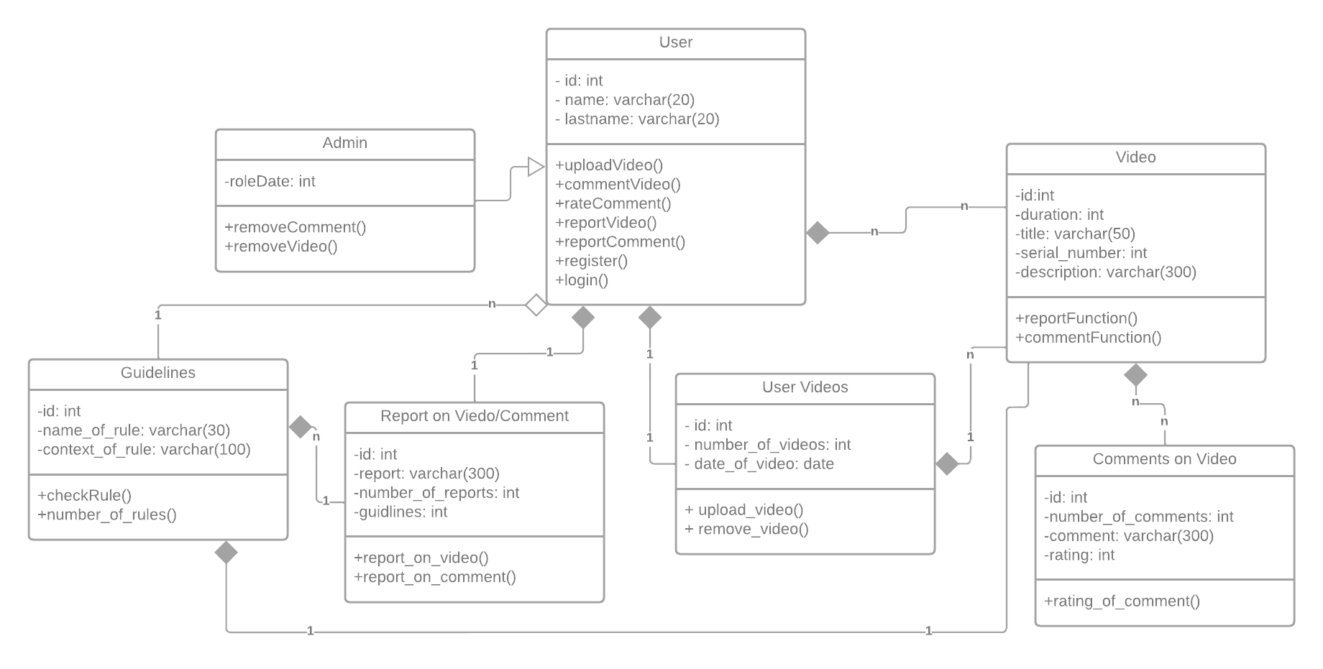

*Figure 3: UML Class Diagram of the system*

**UML Sequence diagram:**

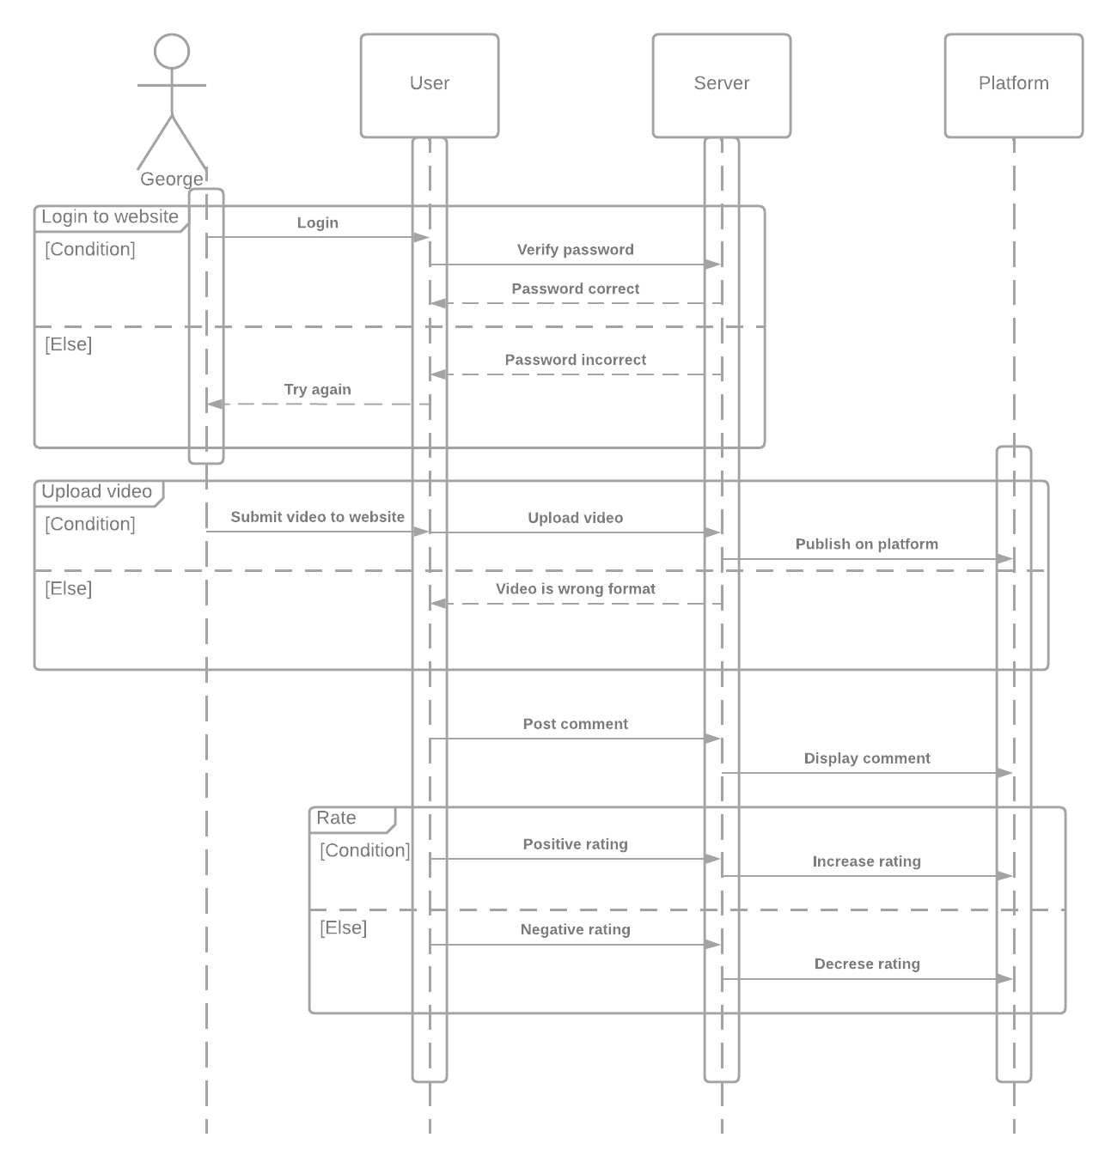

*Figure 4: UML Sequence Diagram of the system*

**Physical database:**

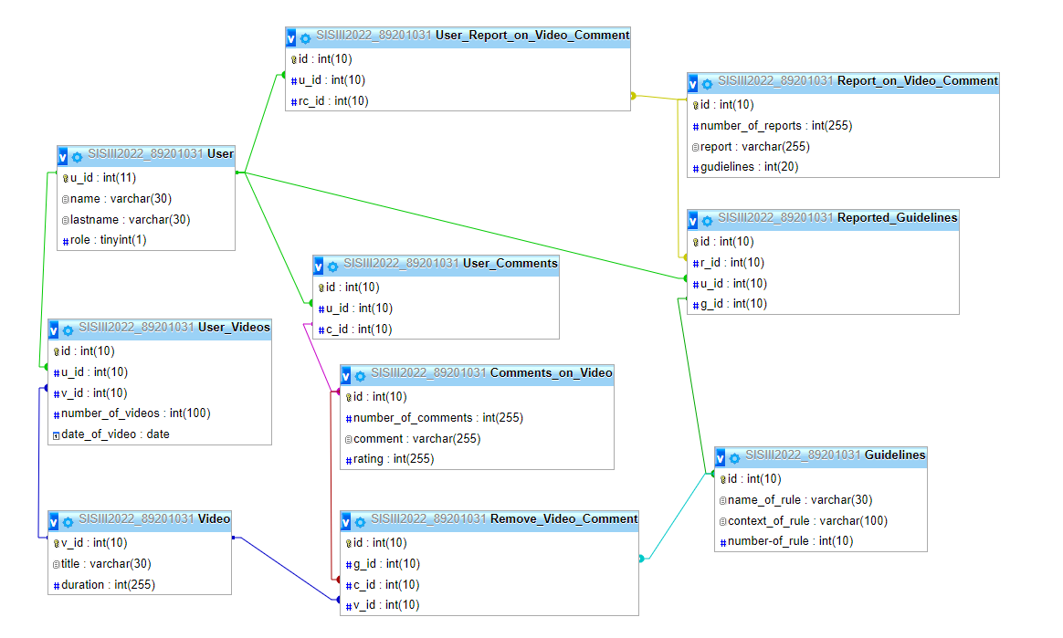

*Figure 4: Physical database of the system*